**Abstract**

Online Book Shop keeps things simple. It's like a virtual store where students can find and buy new books or sell their old ones hassle-free. They don't need to go anywhere else – everything happens on our website. When they want a new book for their courses, they can easily browse and purchase it. And when they're done with their old books, they can sell them to others who might need them. The system takes care of all the technical stuff behind the scenes, ensuring security for transactions. Even for us, managing the shop is easy. We can add or remove books without getting into complicated computer stuff. This makes our project user-friendly and reliable for our college mates.

**Introduction**

In today's digital era, online shopping has made life easier for everyone. But for us students, finding the right books for our studies can still be a hassle. We often end up with stacks of old books we don't need anymore, while also needing to buy new ones for our courses. That's where our Online Book Shop comes in – it's like a virtual store just for students.

Our project is all about making it simple for students to buy new books they need and sell their old ones to others. We've created a website where you can easily find the books you're looking for and get rid of the ones you no longer need. It's a one-stop solution for all your book needs, right from your computer or phone.

With our Online Book Shop, we want to make buying and selling books easy and affordable for students. We believe in making education more accessible and sustainable by promoting the reuse of books. By encouraging the reuse of paper, we're helping to save trees, water, and the environment. Plus, it's a great way for students to connect and help each other out. So, let's get started and make studying a little bit easier for all of us!

**Existing System**

Traditionally, students face various challenges when it comes to acquiring and disposing of their academic books. The current methods of obtaining textbooks often involve visiting physical bookstores, which can be time-consuming and may not always offer the required books. Additionally, purchasing new books can be expensive, particularly for students with limited financial resources. On the other hand, selling old books usually involves cumbersome processes, such as posting advertisements in notice boards or relying on informal networks, leading to inefficiencies and limited reach.

Furthermore, the disposal of old books poses environmental concerns, as the majority of discarded books end up in landfills, contributing to waste accumulation and environmental degradation. This inefficiency in the book acquisition and disposal process not only affects individual students but also impacts the broader educational community and the environment as a whole.

The existing systems for acquiring and disposing of academic books are characterized by inefficiencies, high costs, limited accessibility, and environmental concerns. These challenges highlight the need for a more streamlined and sustainable solution, such as the Online Book Shop, to address the needs of students while mitigating environmental impacts.

**Proposed Solution**

The proposed solution is to develop an Online Book Shop catering specifically to the needs of students. This platform will allow students to buy new books for their courses and sell their old books to others. It will provide a user-friendly interface where students can easily browse through available books, search for specific titles, and complete transactions securely.

The Online Book Shop will offer competitive prices for new books and provide a marketplace for students to sell their used books at reasonable rates. This will address the financial constraints often faced by students while also promoting the reuse of educational materials.

Secure payment gateways will be integrated to ensure the safety of transactions, and user profiles will enable students to manage their orders and track their purchases.

Overall, the proposed solution aims to simplify the process of acquiring and disposing of academic books for students, providing them with a convenient and cost-effective solution tailored to their needs.

**Hardware and Software Requirements**

● **Specific Hardware Requirements**

* Intel/AMD i3 or Above Processor
* HDD/SSD

● **Specific Software Requirements**

* Windows / Linux/MAC/Android
* Any Web Browser 9.0 and Above

❖**Front End:**

* HTML
* CSS
* Bootstrap
* CDN Icons

❖**Back End:**

* Java
* JSP
* Servlet
* MYSQL
* JDBC

**Scope of System**

* **Book Acquisition and Disposal:** The system facilitates the process of acquiring new books for academic courses and disposing of old ones. Users can browse through a catalog of available books, search for specific titles, authors, or subjects, and make purchases or sales within the platform.
* **User Registration and Authentication:** Users can create accounts securely and log in to access the system's features. Authentication mechanisms ensure the security and privacy of user data.
* **User Interface:** The system provides a user-friendly interface accessible via web browsers. This interface allows users to navigate seamlessly through the platform, browse books, manage their profiles, and complete transactions.
* **Book Listing and Management:** Users can list their old books for sale, including details such as title, author, description, price, and availability. Administrators have tools for adding, editing, or removing book listings, as well as managing inventory levels.
* **Transaction Handling:** Secure payment gateways are integrated into the system to facilitate safe and reliable transactions. Users can make purchases or receive payments for sold books securely within the platform.
* **Order Management:** The system tracks the lifecycle of orders from placement to fulfillment. Users can view order status updates, track shipments, and manage returns or cancellations. Administrators monitor order processing and manage inventory accordingly.
* **User Profiles:** Users have personalized profiles where they can manage their account settings, view purchase history, track orders, and communicate with other users.
* **Admin Dashboard:** Administrators have access to a centralized dashboard for managing book listings, monitoring user activity, overseeing transactions, and generating reports on sales performance.
* **Environmental Impact Awareness:** The system aims to raise awareness among users about the environmental impact of book disposal. It promotes sustainability by encouraging book reuse, recycling, and responsible consumption practices.

**Objective of Proposed System**

The objective of the proposed Online Book Shop system is to provide a convenient and user-friendly platform for students to buy new academic books for their courses and sell their old books hassle-free.

* **Simplify Book Acquisition:** The system aims to simplify the process of acquiring academic books by providing a centralized platform where students can easily browse, search, and purchase new books required for their courses.
* **Facilitate Book Disposal:** The system aims to streamline the process of disposing of old academic books by offering a marketplace where students can sell their used books to others who may need them.
* **Promote Sustainability:** By encouraging the reuse of academic books, the system promotes sustainability and helps reduce environmental impact by minimizing book wastage and the need for new book production.
* **Enhance Accessibility:** The system seeks to enhance accessibility to academic resources by providing a virtual platform that is accessible anytime, anywhere, allowing students to buy and sell books conveniently from their computers or mobile devices.
* **Ensure Security:** The system prioritizes the security and privacy of user data and transactions by implementing robust authentication mechanisms and integrating secure payment gateways.
* **Improve User Experience:** The system aims to provide a seamless and intuitive user experience through a user-friendly interface, personalized user profiles, and efficient order management functionalities.
* **Support Community Engagement:** By creating a platform where students can connect with each other to buy and sell books, the system fosters a sense of community and collaboration among college peers.

**State Diagram**

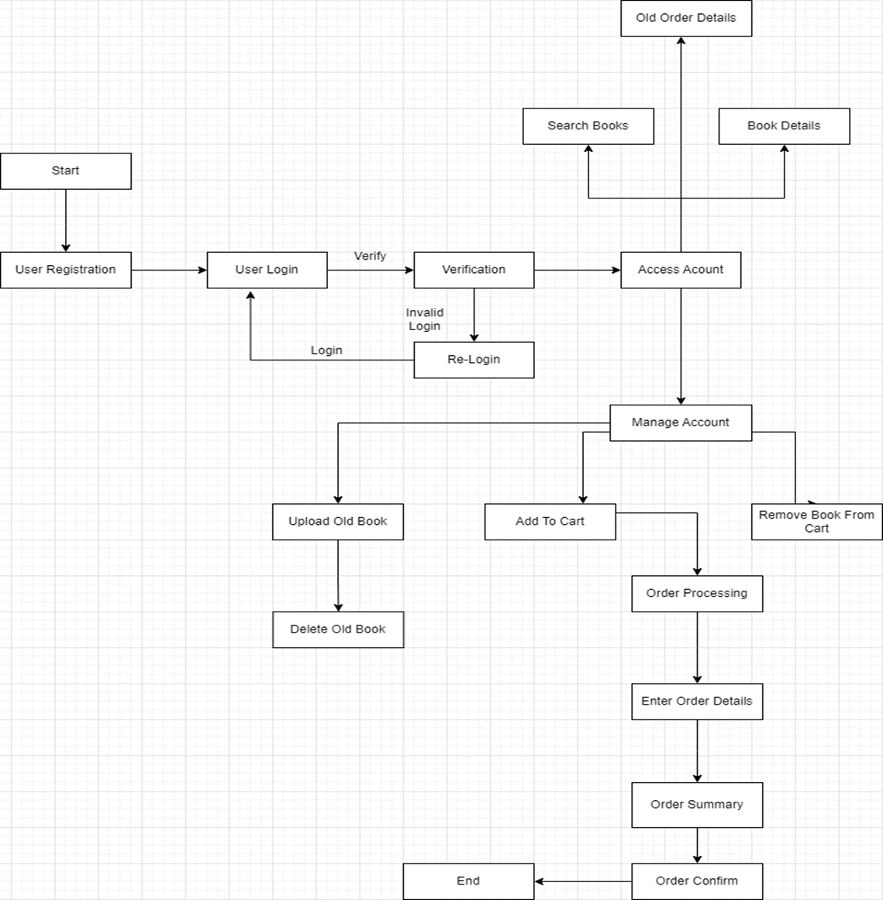

**Component Diagram**

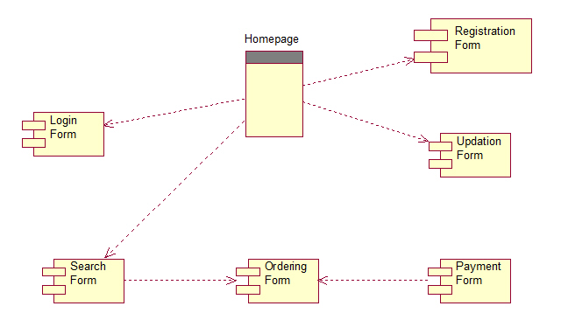

**Collaboration Diagram**

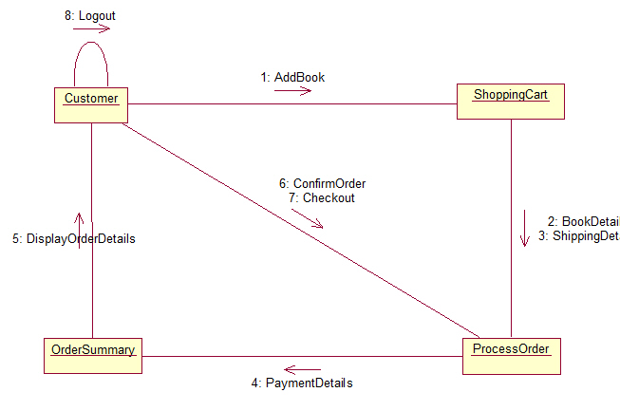

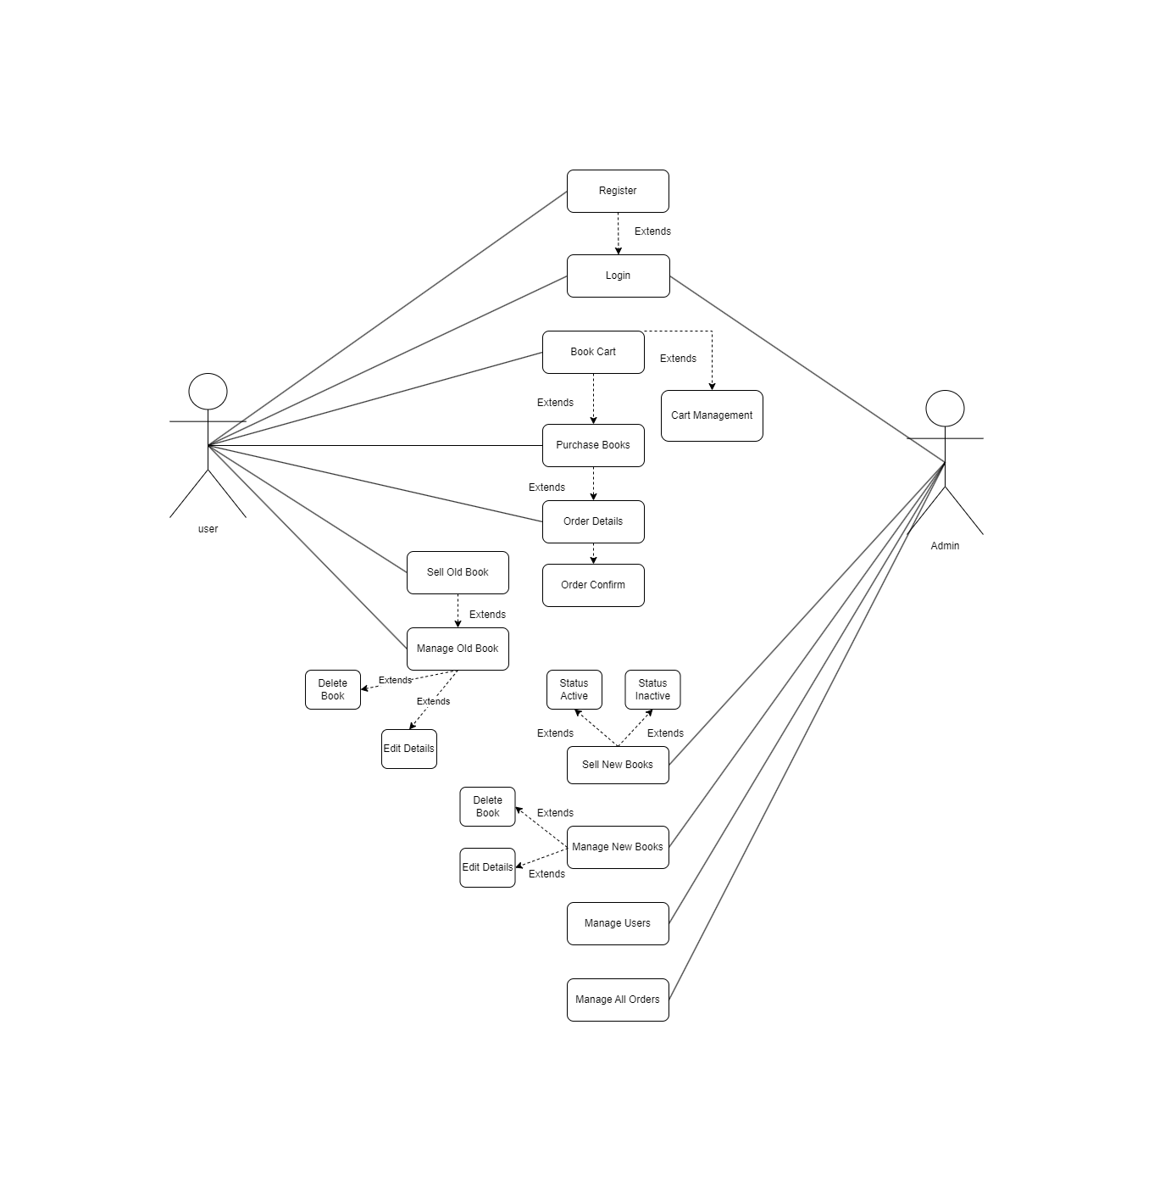**Usecase Diagram**

**Activity Diagram**

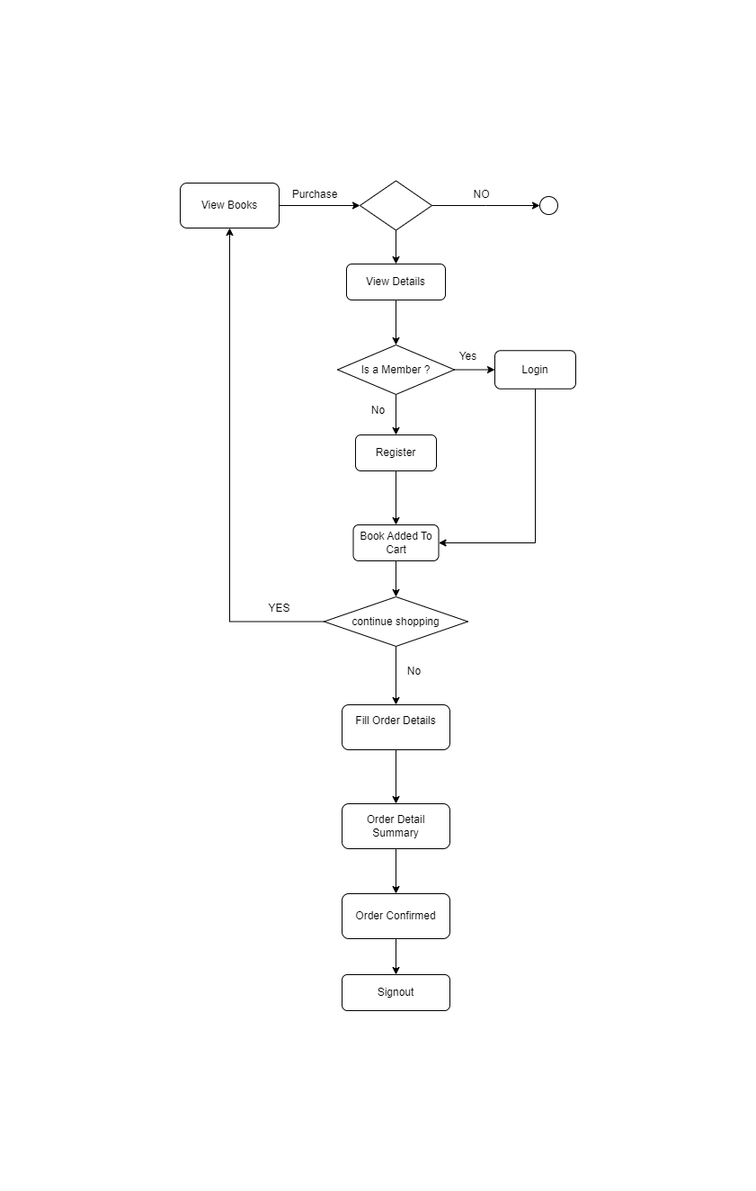

**Order Sequence Diagram**

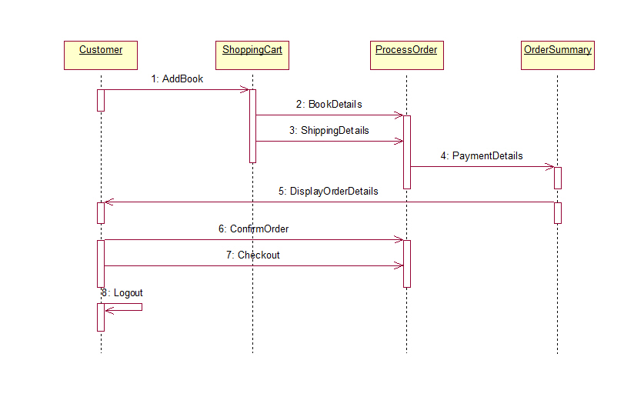

**Database Schema**

**Tables:**

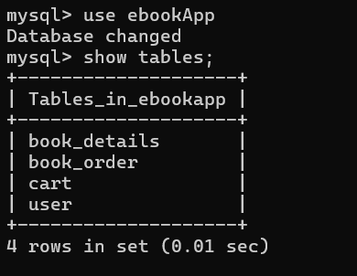

**book_details Table Schema:**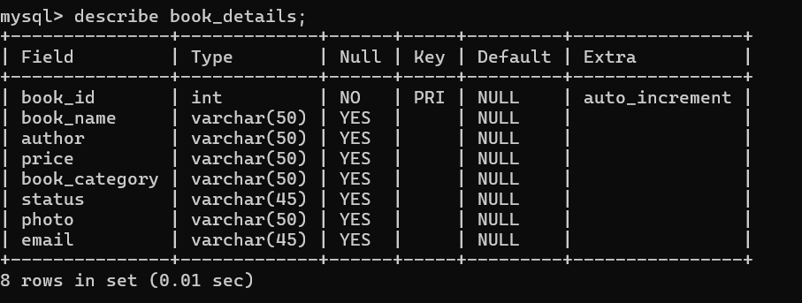

**book_order Table Schema:**

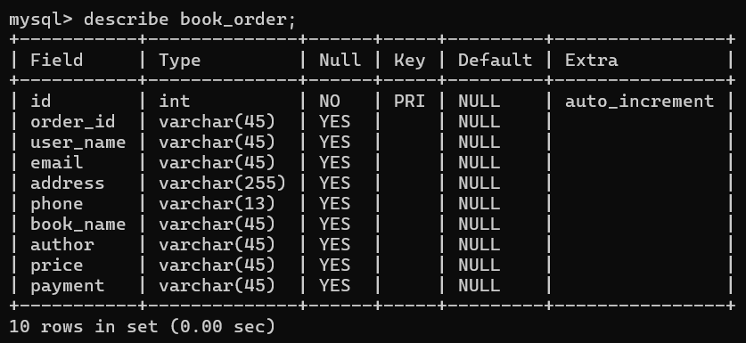

**cart Table Schema:**

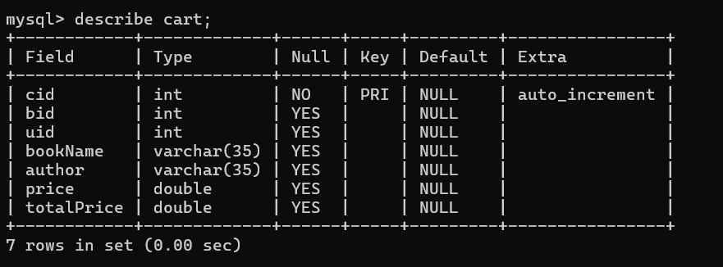

**user Table Schema:**

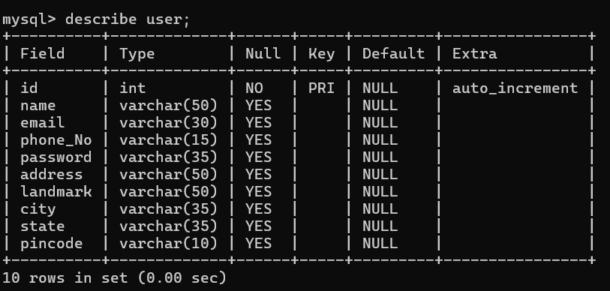

**I/O Screens**

**Home Page**

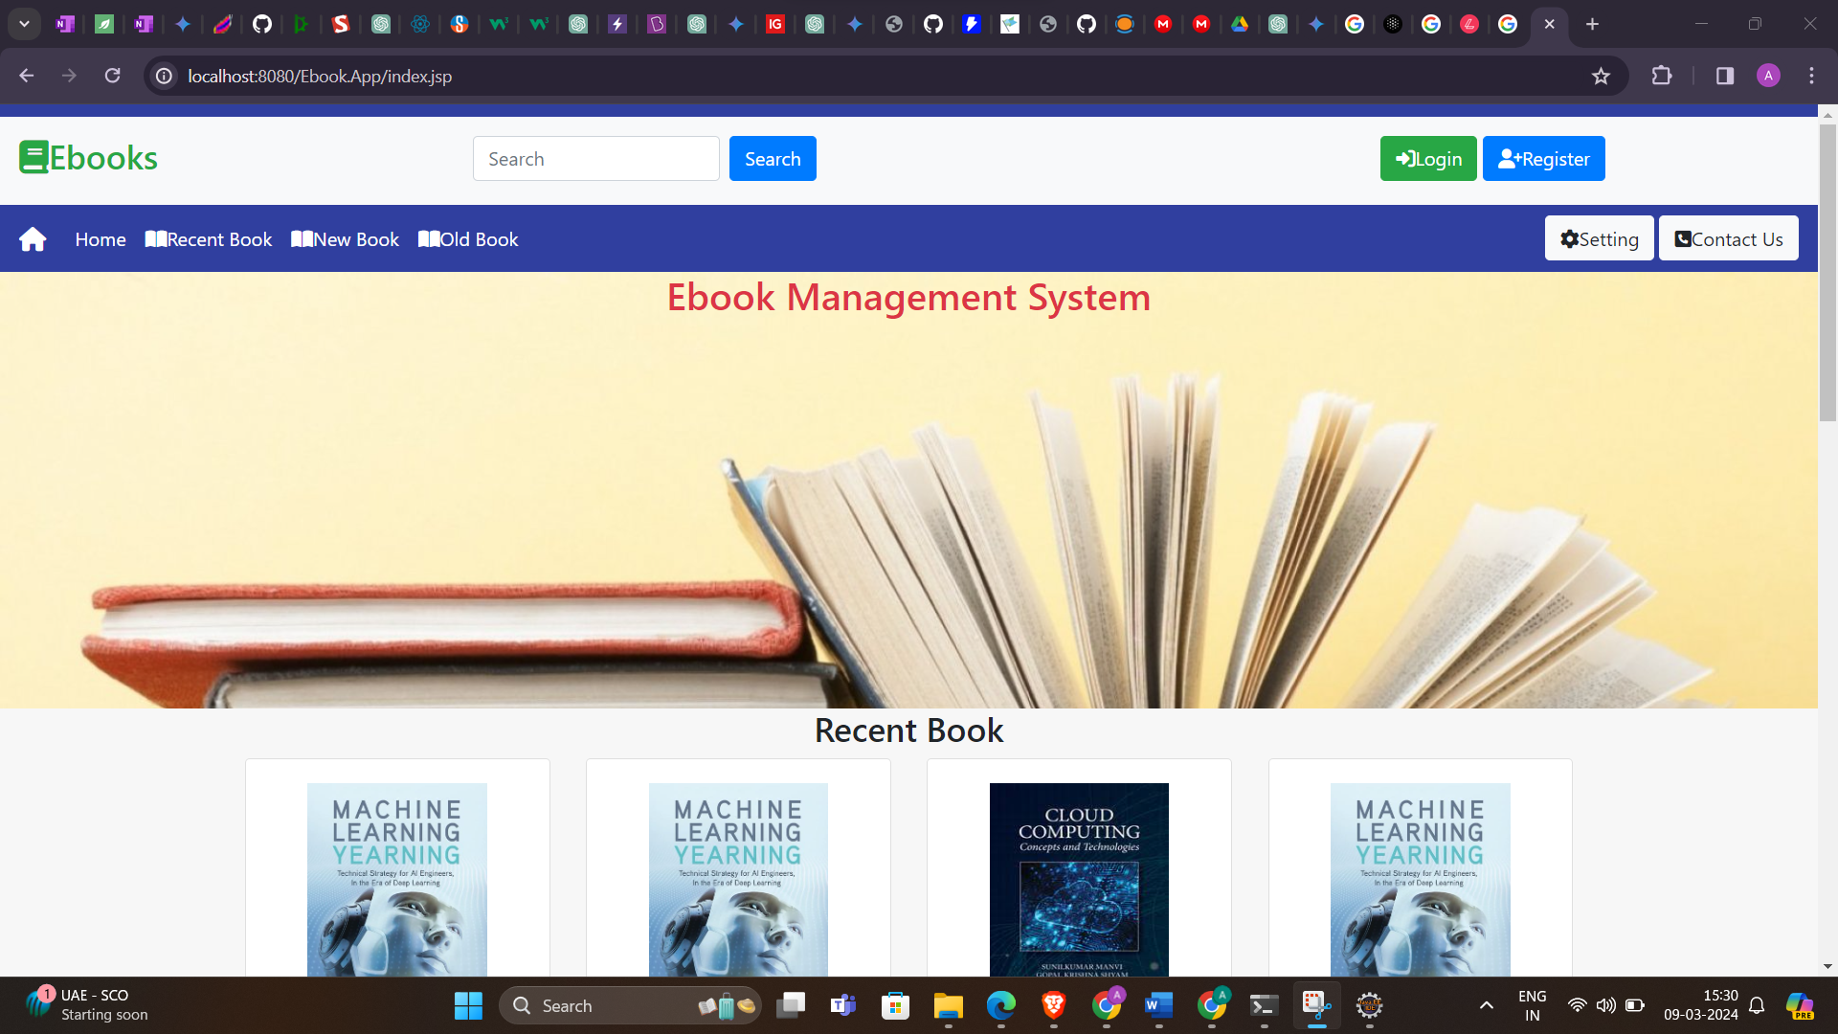

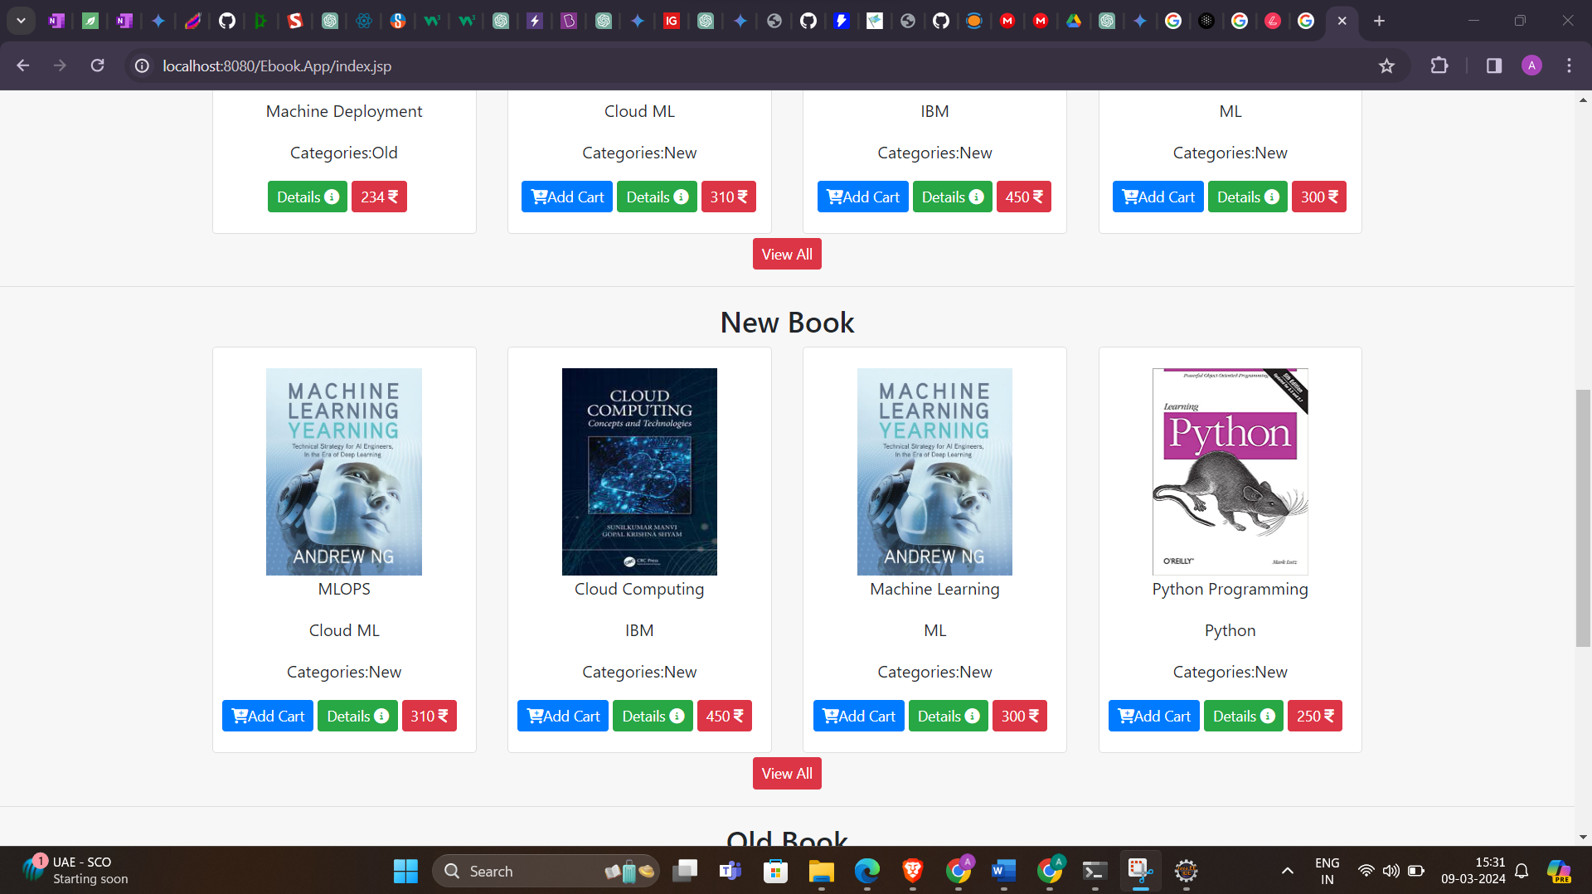**New Books Home Page**

**Old Book Home Page**

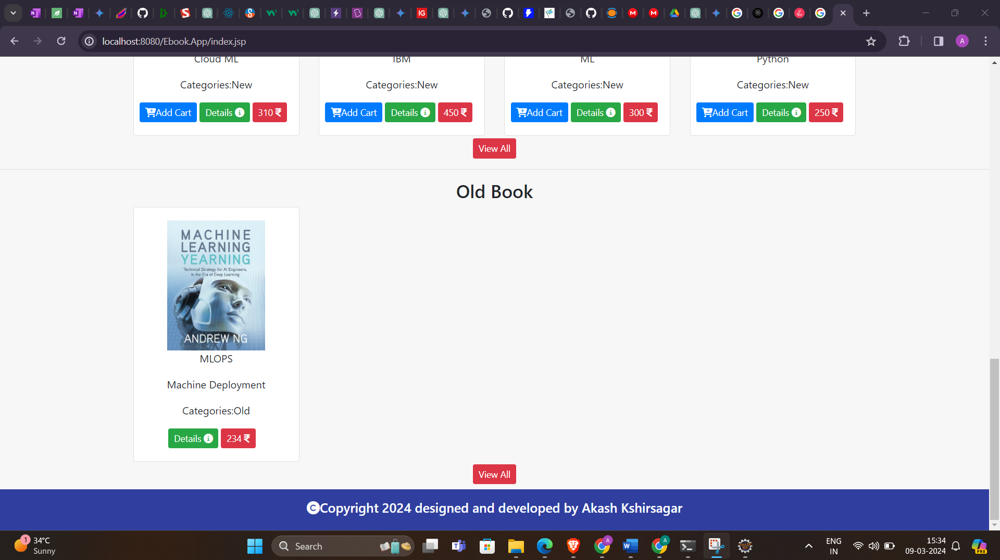

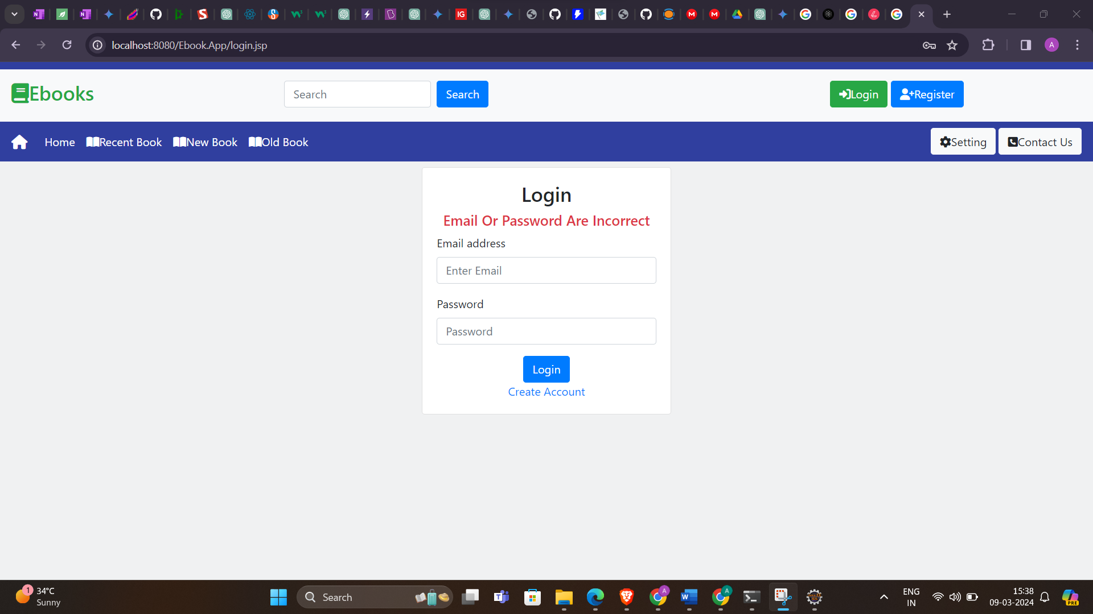**Login And Security**

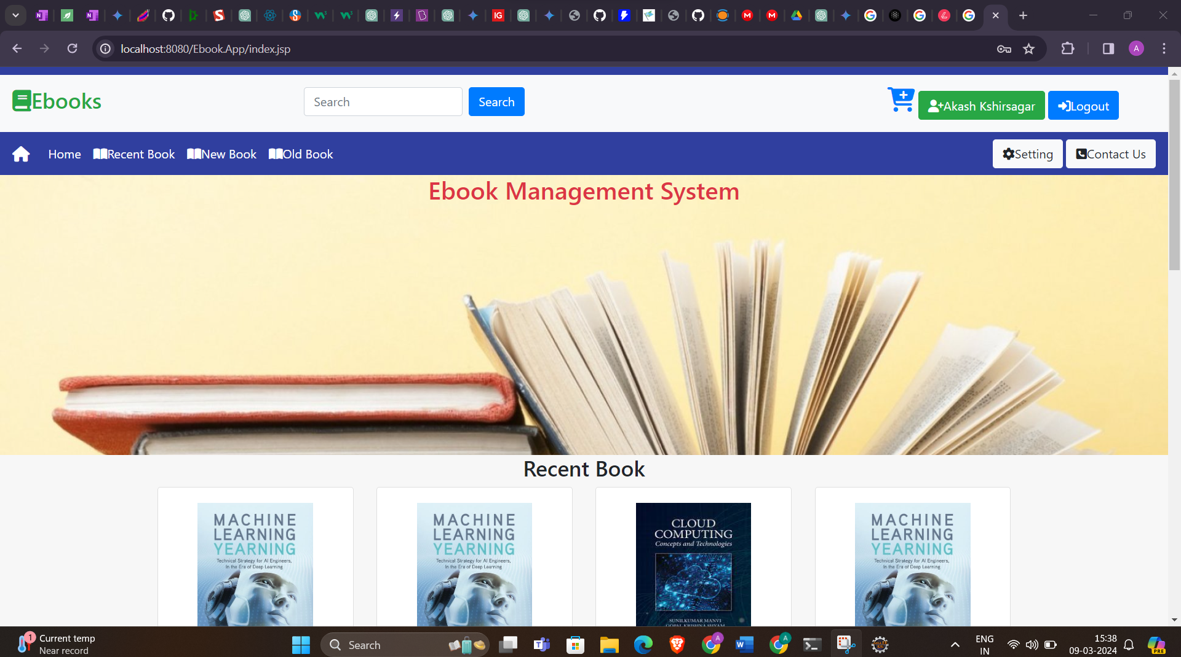**Home Page After Login**

**User Settings**

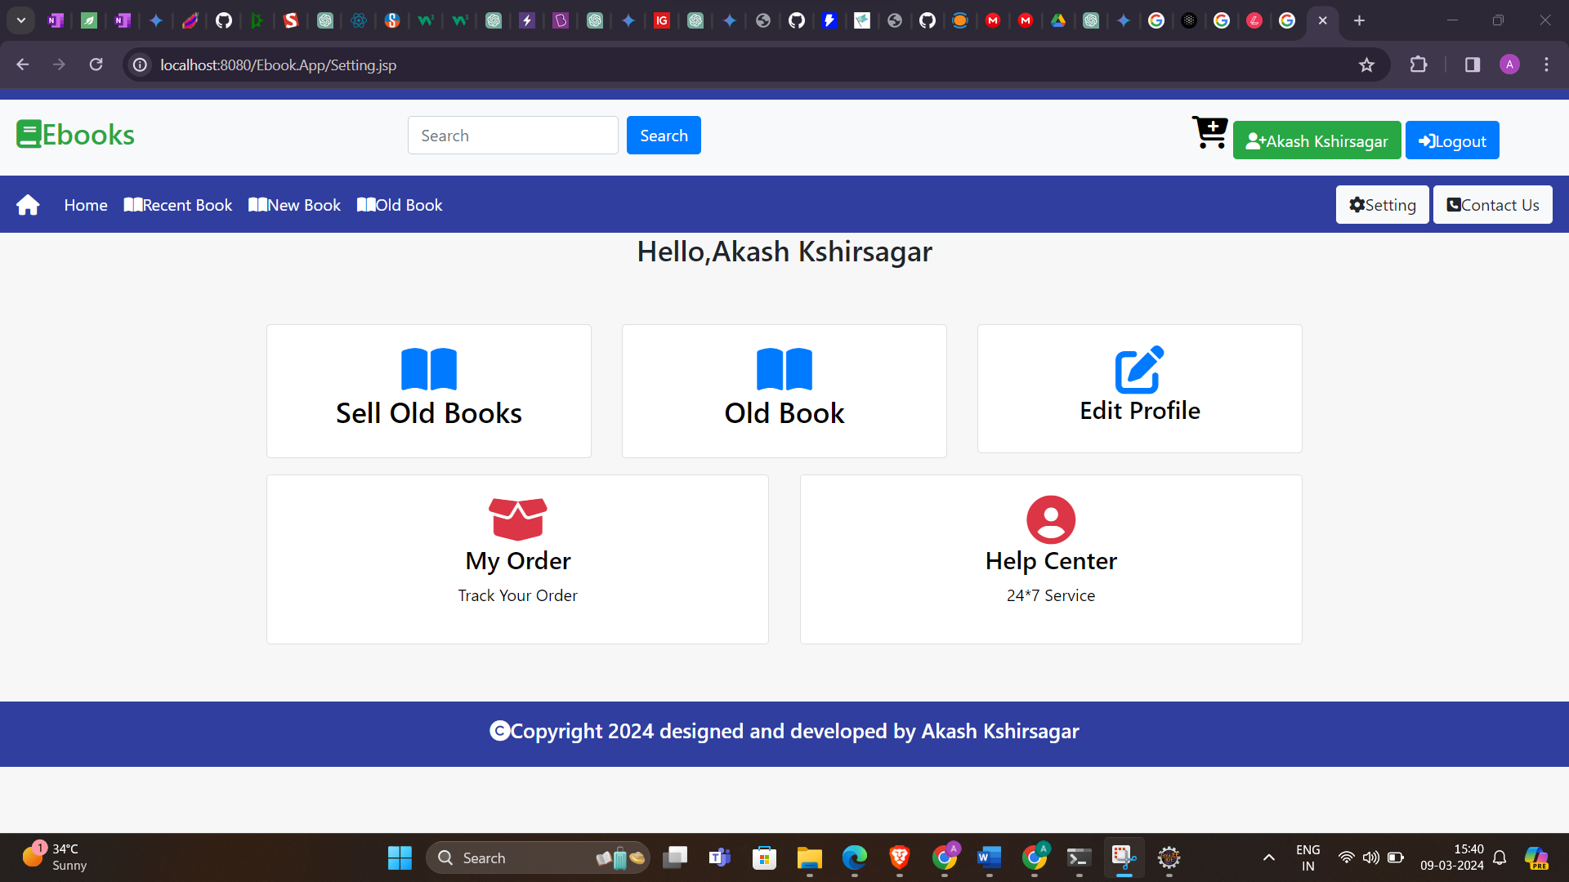

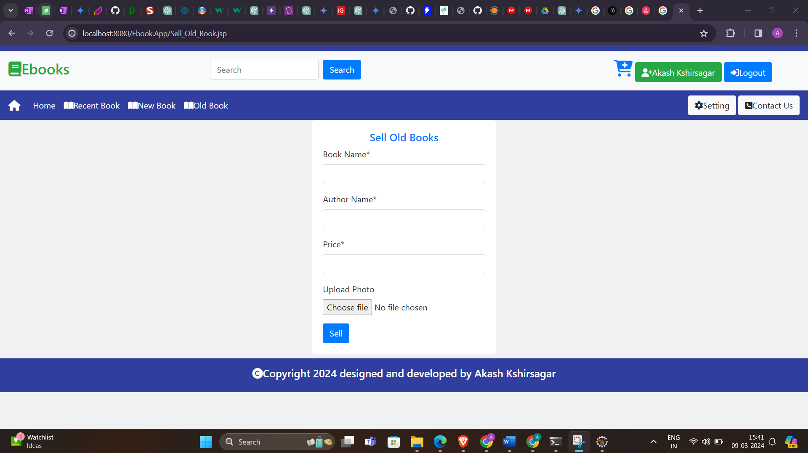**User Sell Old Book Form**

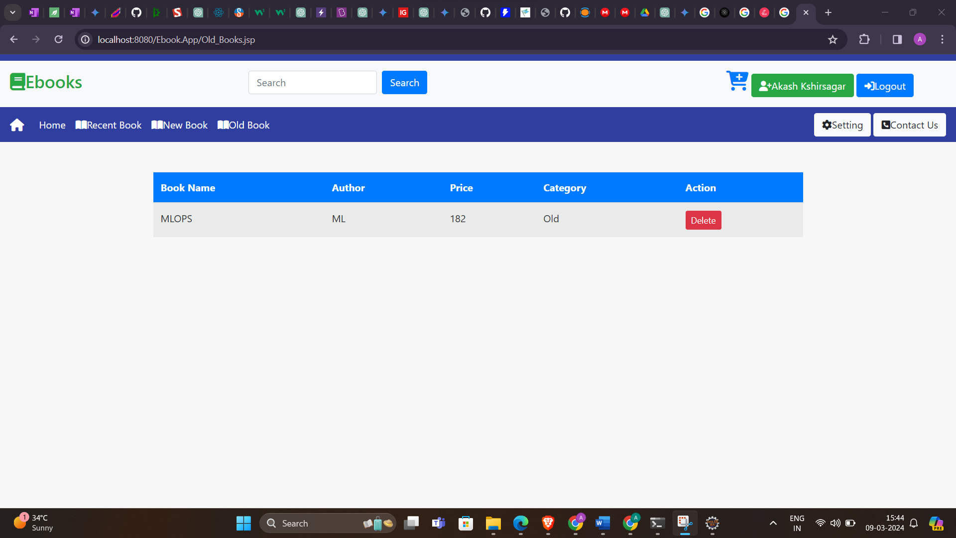**User Old Book Control Panel**

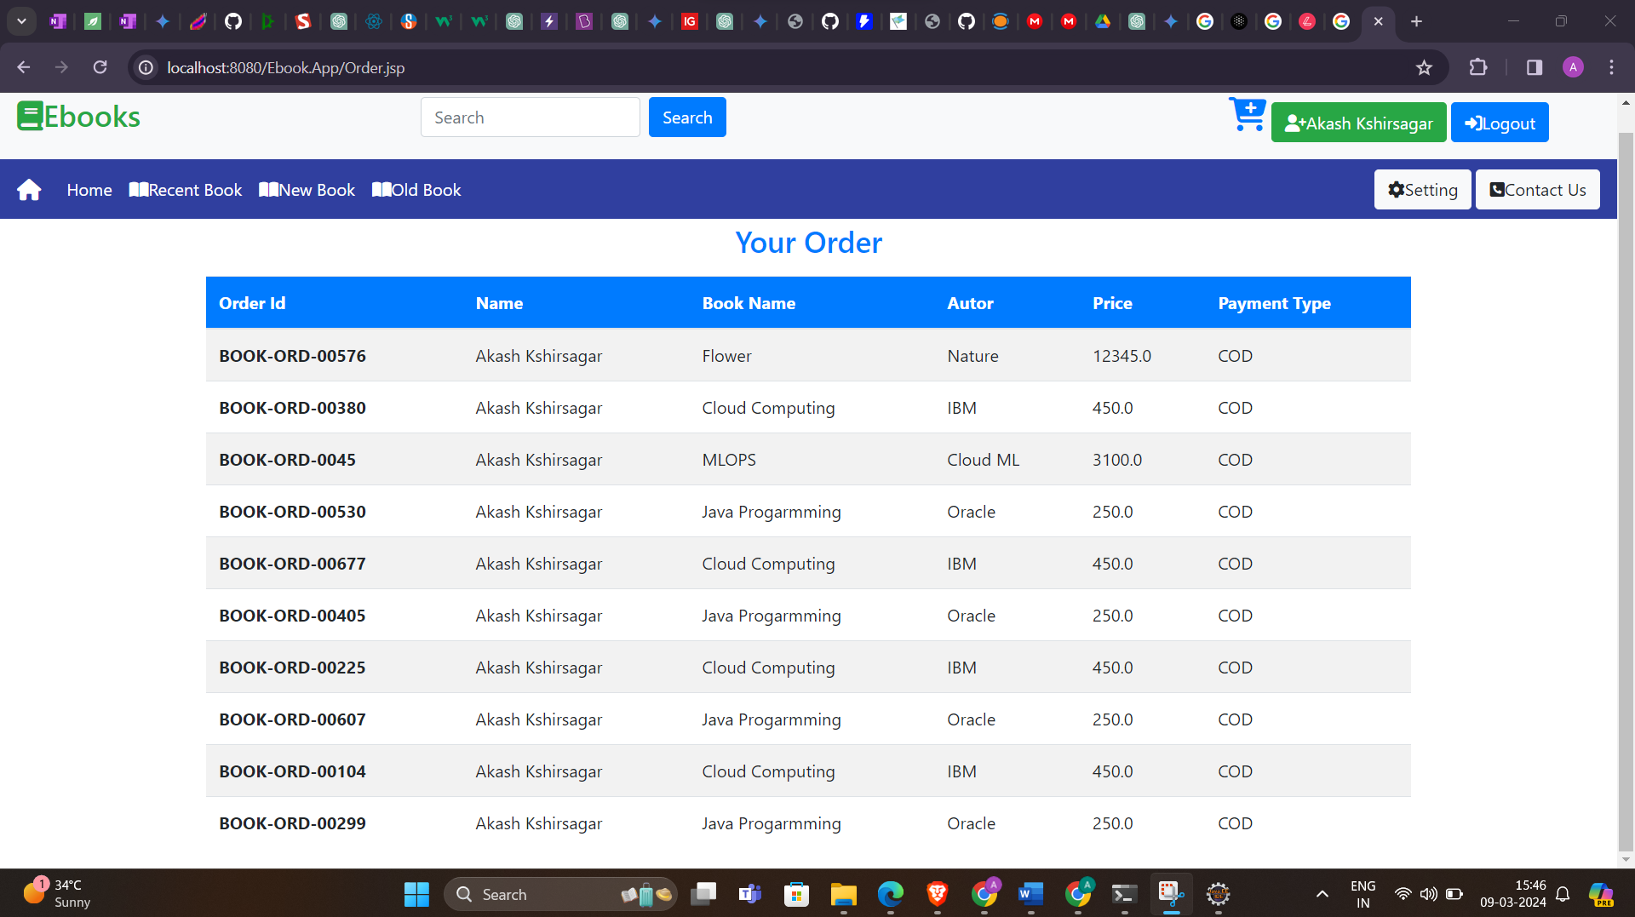**User Previous Order Details**

**User Cart**

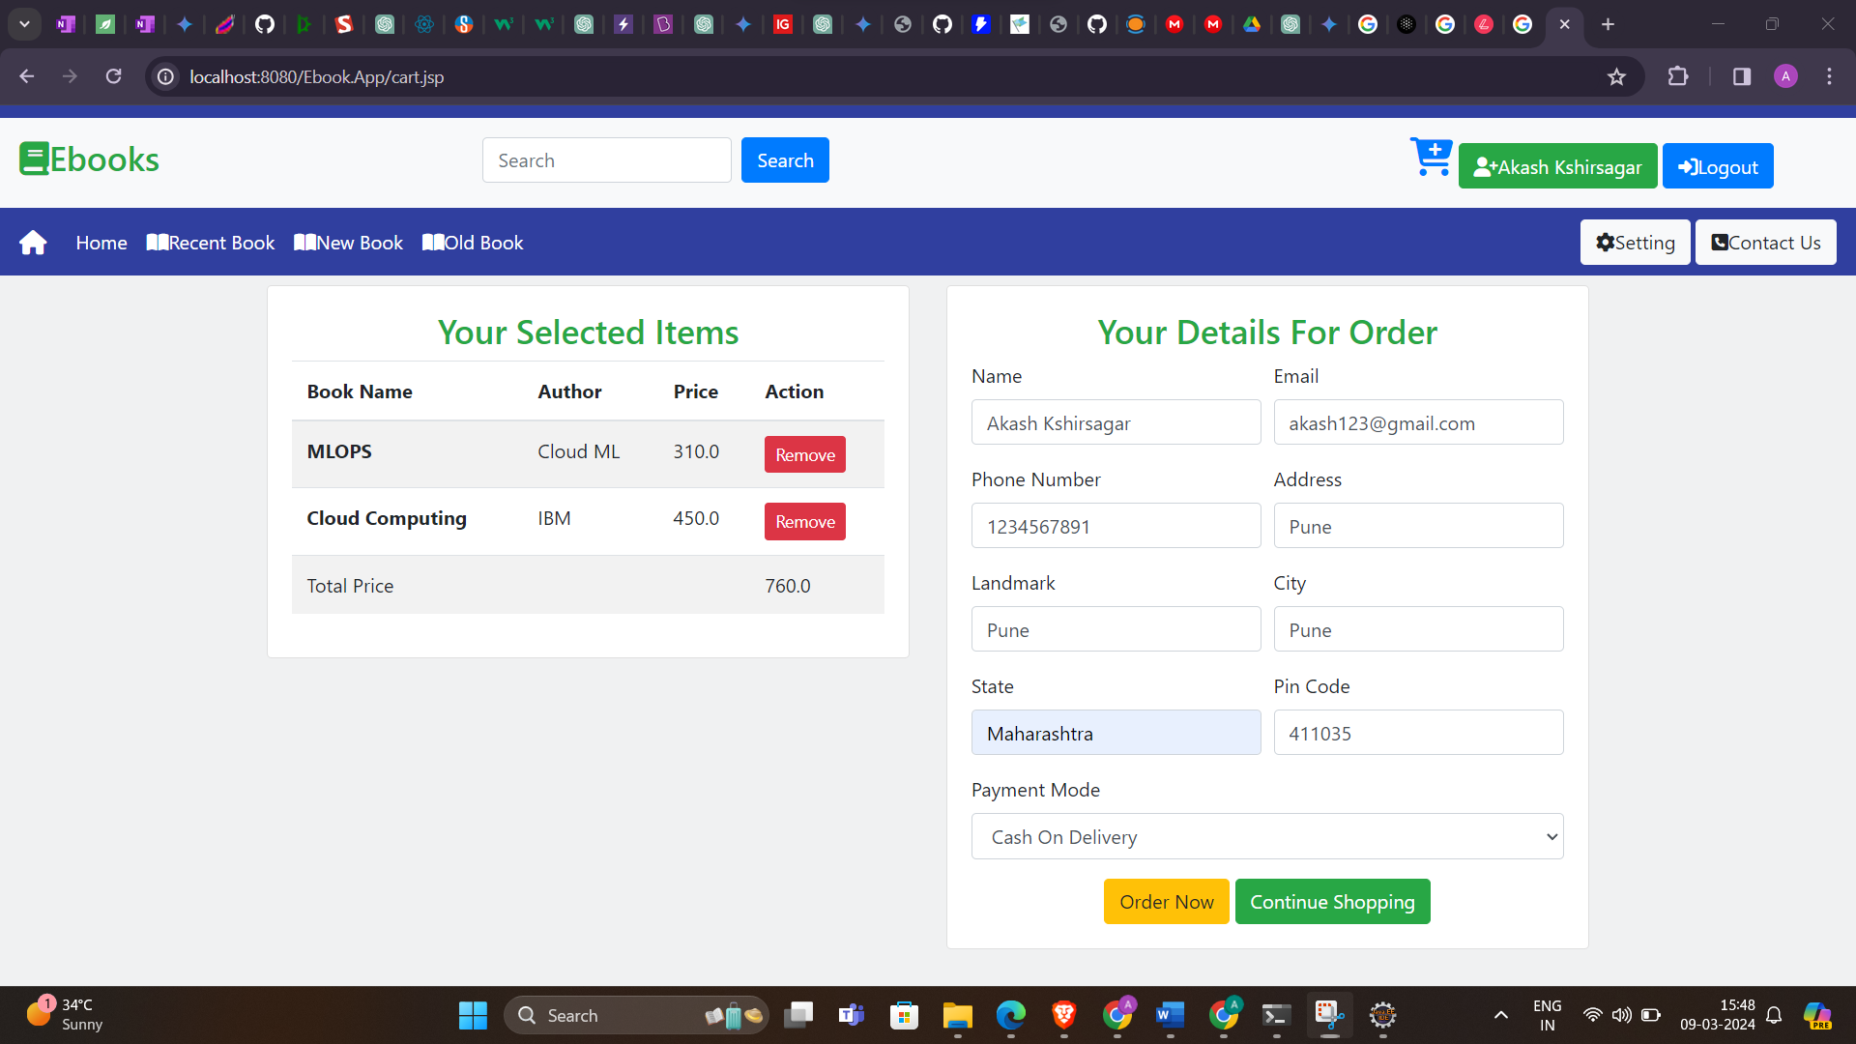

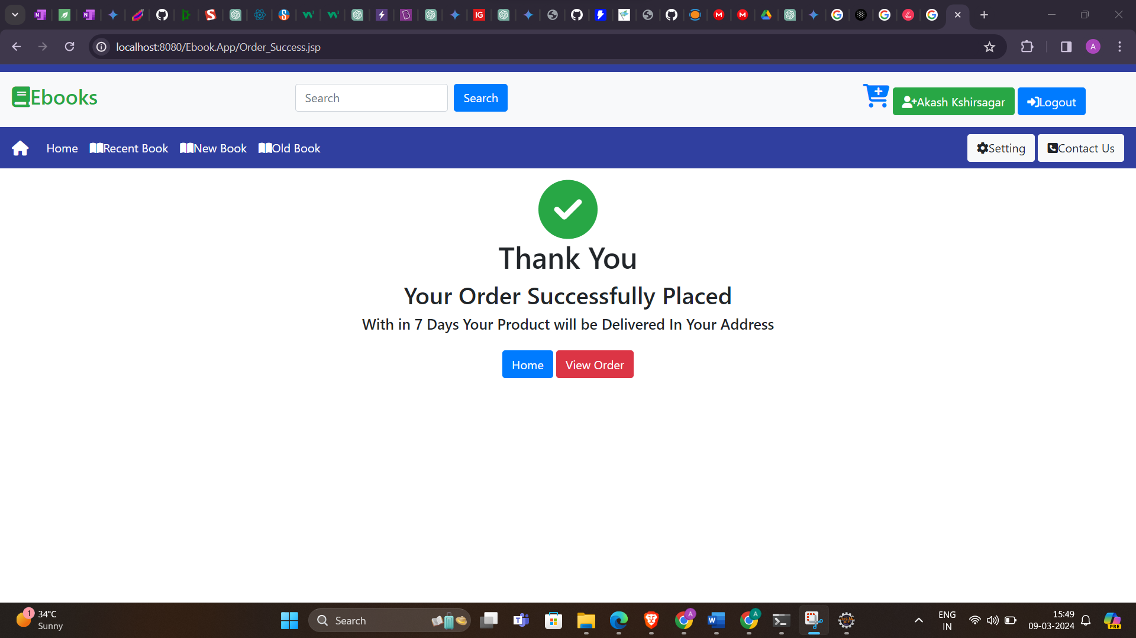**User Placed Order**

**User Logout**

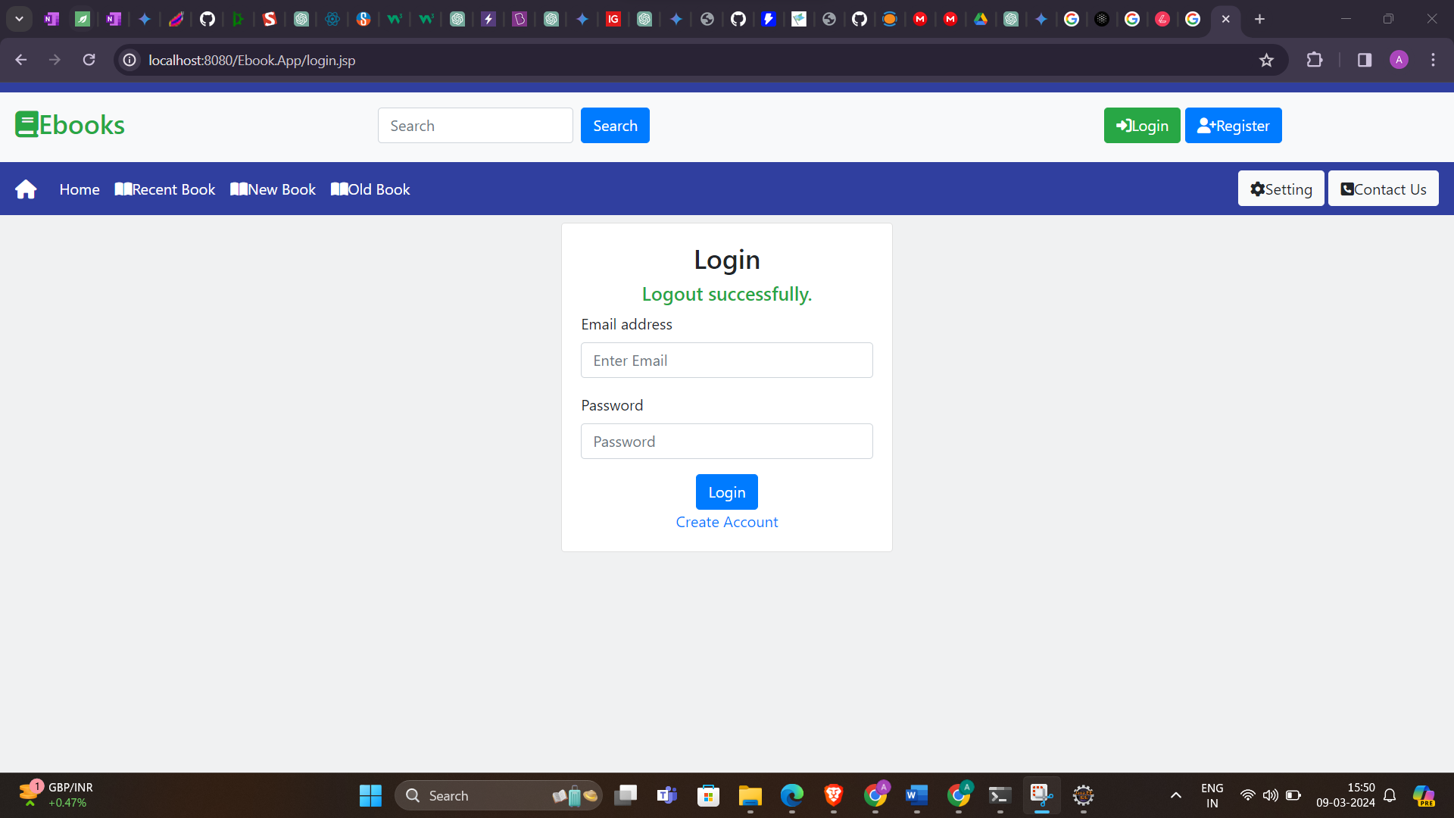

**Admin Login**

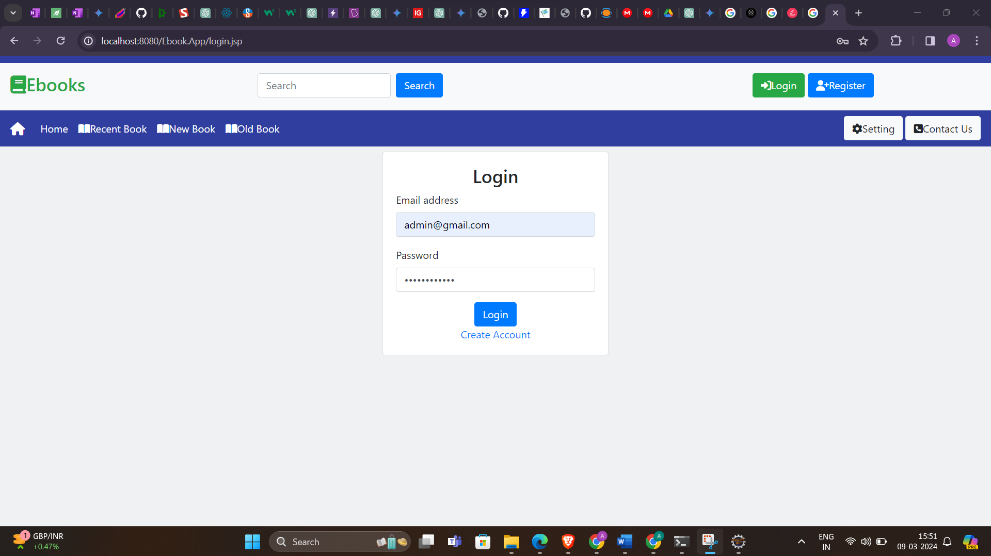

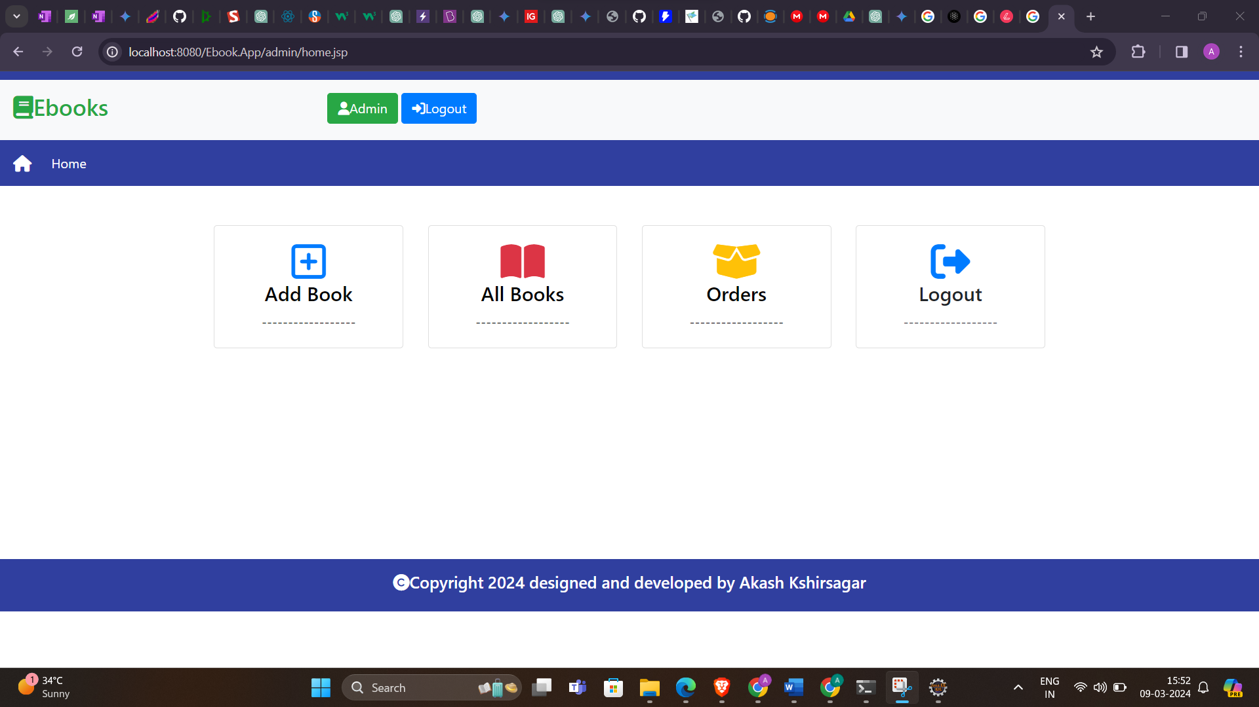**Admin Panel**

**Admin Add New Books Form**

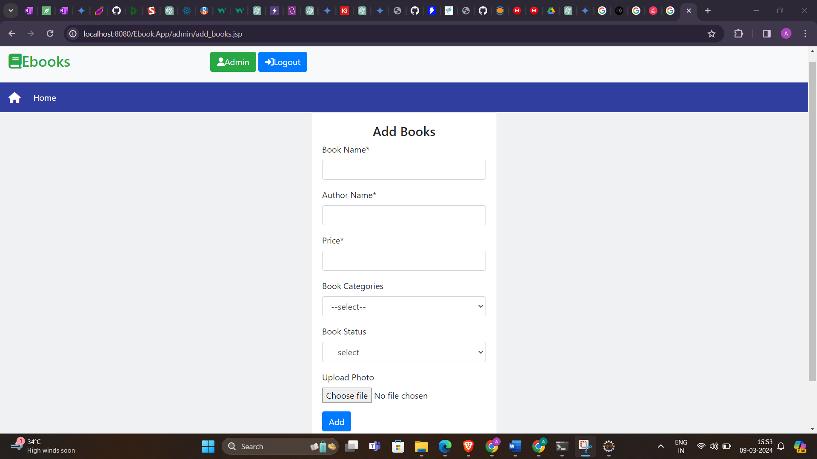

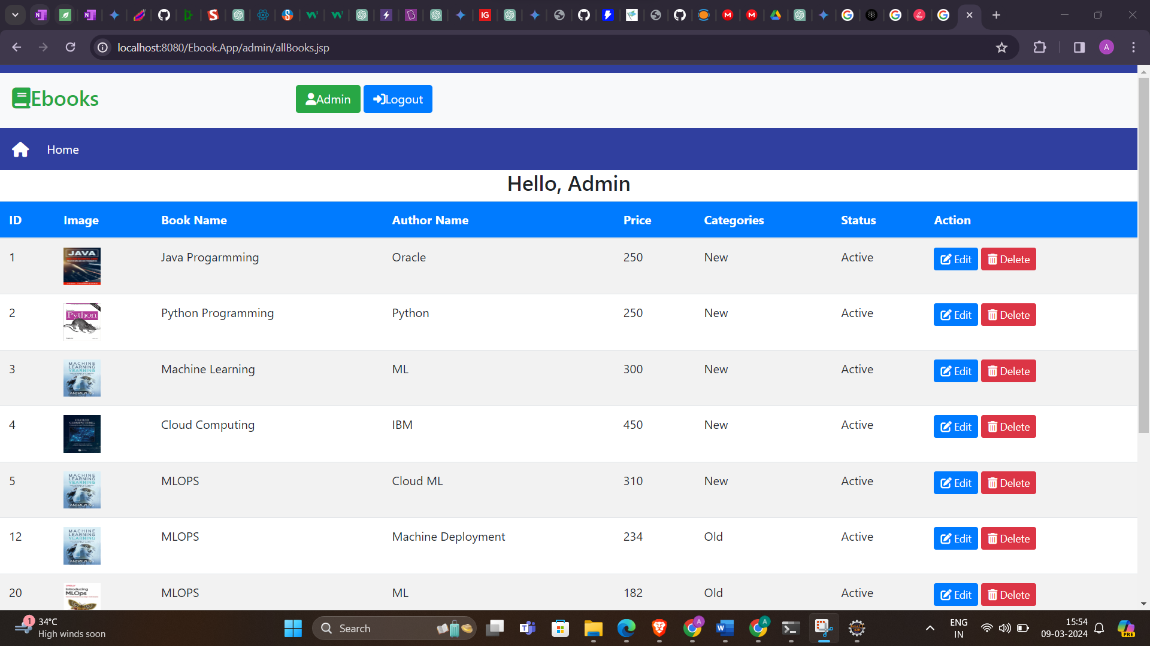**Admin All Books Control Panel**

**Admin Edit Book Panel**

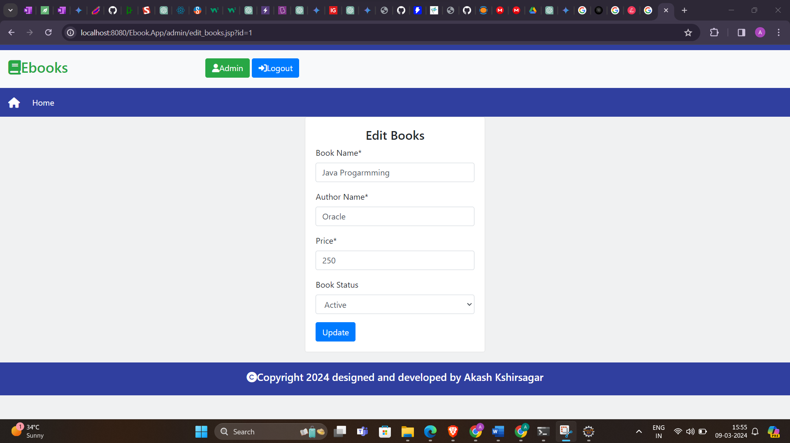

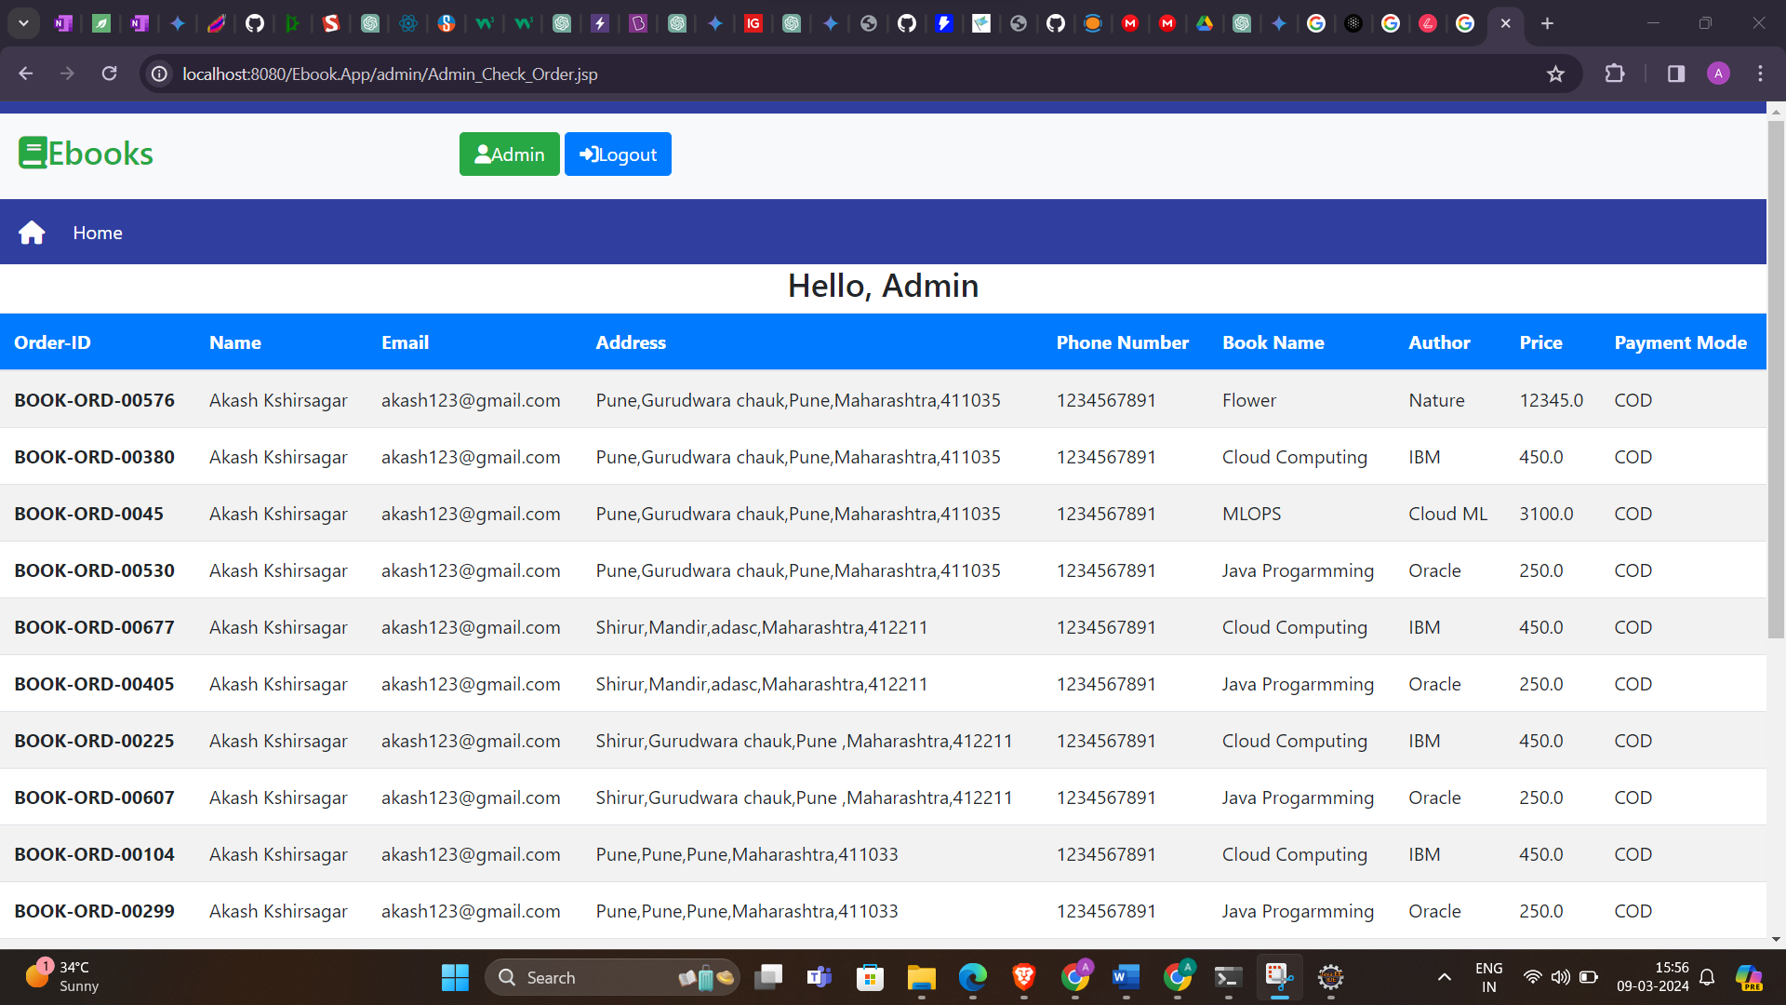**Admin All Order Details Panel**

**Future Enhancements**

* **Integration of Advanced Search Features:** Enhance the search functionality to include filters such as price range, publication date, and book condition to provide users with more precise search results.
* **Implementing User Reviews and Ratings:** Allow users to leave reviews and ratings for books they have purchased, enabling others to make informed decisions based on peer feedback.
* **Introducing Wishlists and Book Recommendations:** Enable users to create wishlists of books they are interested in purchasing and provide personalized book recommendations based on their browsing and purchase history.
* **Expanding Payment Options:** Integrate additional payment gateways such as PayPal, Google Pay, or UPI to offer users more flexibility in making payments.
* **Enhancing Admin Dashboard Functionality:** Expand the capabilities of the admin dashboard to include advanced analytics, sales reports, and inventory management tools for better decision-making.
* **Implementing Social Media Integration:** Allow users to share their favorite books or purchases on social media platforms, increasing visibility and engagement with the platform.
* **Introducing Book Rental Services:** Expand the platform to include a book rental feature, allowing users to rent books for a specified duration instead of purchasing them outright.
* **Implementing Mobile Applications:** Develop mobile applications for iOS and Android platforms to provide users with a seamless and optimized experience on mobile devices.
* **Integrating AI-based Book Recommendation Systems:** Implement artificial intelligence algorithms to analyze user preferences and behavior and provide personalized book recommendations tailored to individual users.
* **Enhancing Accessibility Features:** Ensure compliance with accessibility standards such as WCAG (Web Content Accessibility Guidelines) to make the platform accessible to users with disabilities.

**Conclusion**

In conclusion, the Online Book Shop system represents a significant step forward in addressing the challenges faced by students in acquiring and disposing of academic books. By providing a centralized platform for buying and selling books, the system simplifies the process and enhances accessibility, convenience, and affordability for students. Moreover, by promoting the reuse of books, the system contributes to sustainability efforts by reducing environmental impact.

Through its user-friendly interface, secure transactions, and efficient management functionalities, the Online Book Shop system aims to improve the overall experience for students and foster a sense of community among college peers. By leveraging technology to streamline book acquisition and disposal processes, the system not only meets the immediate needs of students but also supports broader educational goals of accessibility, affordability, and environmental responsibility.

As we move forward with the implementation and deployment of the Online Book Shop system, it is essential to remain committed to ongoing improvements, user feedback, and sustainability initiatives. By continuously refining and expanding the system's features and capabilities, we can ensure that it remains a valuable resource for students and contributes positively to their academic journey and the environment as a whole.